Note: Work must be performed in accordance with this SWMS, and it must be available for inspection until the work to which this SWMS relates is completed. If the SWMS is revised, all versions are to be kept.

TK Elevator Australia Pty Ltd – QLD | ABN: 12 073 056 149 |  |  |  | SWMS # | R04
Work Activity: | Balance lift car |  |  | SWMS Issue Date: | <0/0/0>
Project: | <job name> |  |  | SWMS Review Date: | 07/04/26
SWMS Developed By: | Peter Lawrence | Position: | QLD Safety Manager | Developed Date: | 01/12/21

SWMS Approved By
Name: | Christian Nesseler | Signature:
Role / Position: | QLD Renew Supervisor | Date: | <0/0/0>

High risk construction work: | ☐ Risk of a person falling more than 2m (note: in some jurisdictions this is 3m) |  | ☐ Work on a telecommunication tower |  |  |  | ☐ Work on a telecommunication tower
 | ☐ Likely to involve disturbing asbestos |  | ☐ Temporary load-bearing support for structural alterations or repairs |  |  |  | ☐ Work in or near a confined space
 | ☐ Work in or near a shaft or trench deeper than 1.5m or a tunnel |  | ☐ Use of explosives |  |  |  | ☐ Work on or near pressurised gas mains or piping
 | ☐ Work on or near chemical, fuel or refrigerant lines |  | ☐ Work on or near energised electrical installations or services |  |  |  | ☐ Work in an area that may have a contaminated or flammable atmosphere
 | ☐ Tilt-up or precast concrete elements |  | Work on, in or adj to a road, railway, shipping lane or other traffic corridor in use by traffic other than pedestrians |  |  |  | ☐ Work in an area with movement of powered mobile plant
 | ☐ Work in areas with artificial extremes of temperature |  | ☐ Work in or near water or other liquid that involves a risk of drowning |  |  |  | ☐ Diving work
Change Management This SWMS must be reviewed when controls are potentially not effective (e.g. an incident occurs, work not in accordance with the SWMS etc.), changes to the workplace occur that introduce new hazards, or as required by the client’s system in order to keep the SWMS current to the work activity being undertaken.
Name |  | Signature |  | Date | Name | Signature |  | Date

Training / skills required
Inductions: | TKE |  | Client |  | ☐ | Site | ☐ |  | Other: |  |  | Vehicle/Plant | Licence | ☐ | Competency Assessment | ☐ | List:
Trade Qualification(s) | List: Lift Technician Electrical, fitter |  |  | Task Specific Competencies |  |  |  |  |  | List: TKE GSM (Global Safety Manual) OHS Induction; Manual Handling Practices; General Construction Induction; Site Specific Induction (if applicable); Work Activity Induction – SWP (various); First Aid / CPR Training; Work at Heights Training
Equipment Required | List: Hand tools

Health and Safety 10 Rules
☐ | ☐ | ☐ |  |  | ☐ |  |  | ☐
Lock Out / Tag Out (LOTO) | Fall Protection | Jumpers | PPE  (specify below) | Car Top and Pit Access | Live Electrical / Troubleshooting | Mechanical Stored Energy | Rigging & Hoisting | False Cars & Running Platforms | Barricading
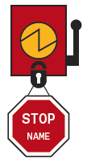 | 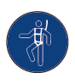 | 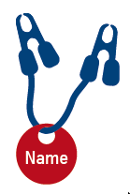 | 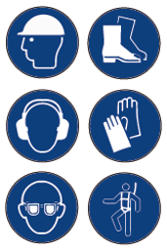 | 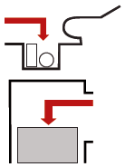 | 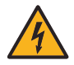 | 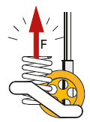 | 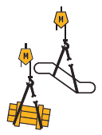 | 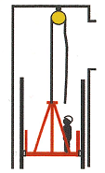 | 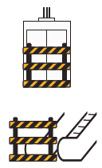

Personal Protective Equipment (PPE) – Required for task
Uniform – long sleeves, long pants | Safety footwear AS/NZS 2210.3 | High-Vis  AS/NZS 1906.4 | Hard hat  AS/NZS 1801 | Safety eyewear  AS/NZS 1337 | Gloves – to always be carried | Fall arrest | Hearing | Face mask  (P2/N95) | Respirator  (P2/N95) | Face shield | Low/High Voltage Gloves | Other  (specify)
 | 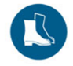 |  | 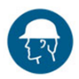 |  |  | 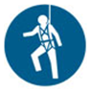 |  | 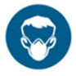 | 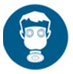 | 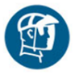 | 
 |  | ☐ | ☐ |  |  | ☐ |  | ☐ | ☐ | ☐ | ☐ | ☐

Risk Matrix
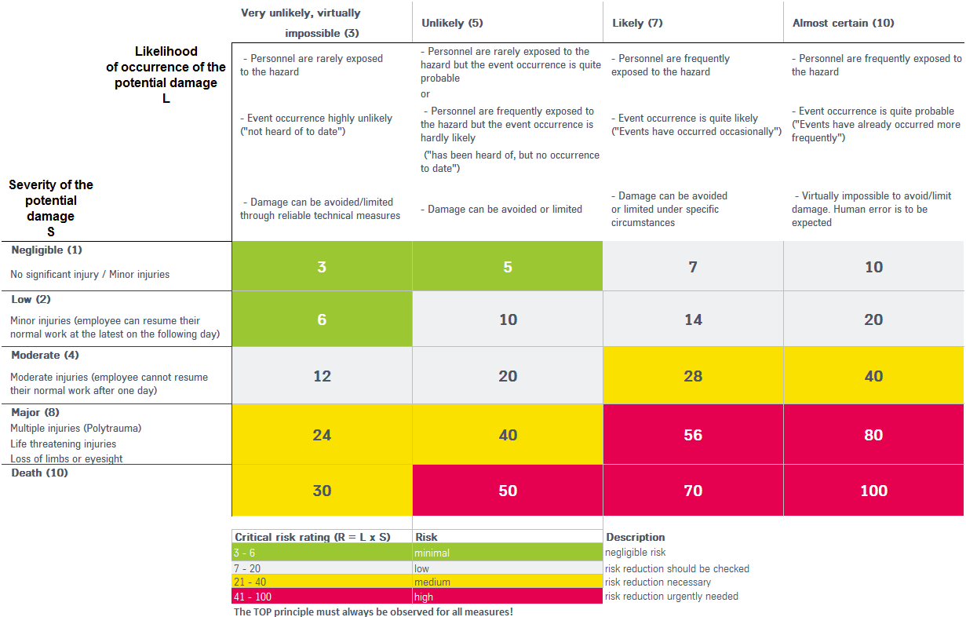

Hierarchy of Control
The hierarchy of control assists a person identify and choose a control that provides the highest level of safety possible. Note: there maybe more than one method of control. A control higher up the hierarchy will be a more effective control in the long run. Administrative and PPE controls are the least effective and only marginally manage the risk.
- Elimination – can the hazard be eliminated or completely removed?  - If the hazard cannot be eliminated, then can the risk associated through the hazard be mitigated through one or a combination of one of the following?  - Substitution – replacing a thing with something else.  - Isolation – separating a person or object from something.  - Modification / Re-Design – changing something or re-designing it in another way. Could be an object, process or something else.  - Administration – includes work or written procedures, policies, rules, signage, training or information.  - PPE (Personal Protective Equipment) – clothing or equipment designed to be worn to protect a person from the risk of injury or illness and can include helmets, ear plugs / muffs, eye or face protection, gloves, safety boots and respiratory protective equipment. | Risk Control  Risk Management | 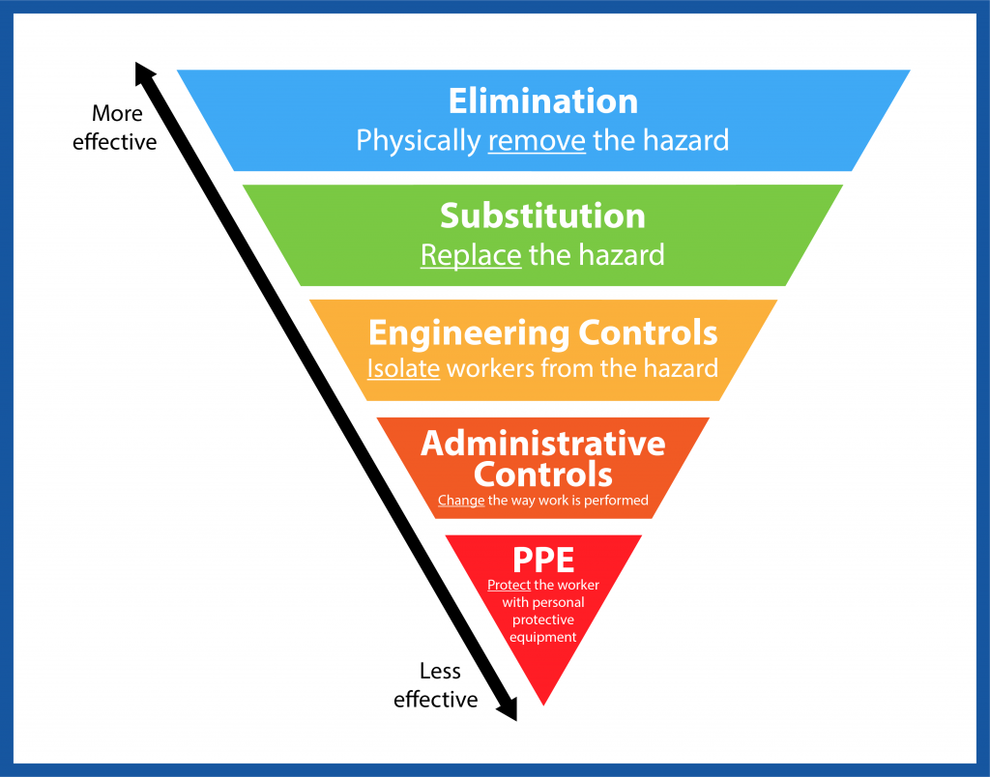

Codes of Practice | Standards | Other
- COP: Managing the Risk of Plant in the Workplace  - COP: WH&S Consultation and Co-Operation  - COP: Hazardous Manual Tasks  - COP: How to Manage Health and Safety Risks  - COP: Managing Noise Preventing Hearing Loss  - COP: Managing the Work Environment and Facilities  - COP: Preparation of Safety Data Sheet Hazardous Chemical  - COP: Managing the risk of falls at workplaces  - COP: Electrical Safety – Works  - COP: Managing Electrical Risk in the Workplace  - COP: Managing Respirable Crystalline Silica Dust in Construction and Manufacturing  - COP: How to Control and Manage Asbestos in the Workplace  - COP: Managing the risk of Psychosocial Hazards at Work  - OH&S Induction Training for Construction Work  - National Standard & Code of Practice for Manual Handling  - National Standard & Code of Practice for Occupational Noise | - AS 1735.2:2001 – Passenger and Goods Lifts - Electric  - AS 3760:2010 – In service safety inspection and testing of electrical equipment  - AS 4431:2019 - Guidelines for safe working on new lift installations in new constructions  - ISO31000 – Risk Management Principles  - AS/NZS 3000:2018 – Electrical installations (Australian/New Zealand Wiring Rules)  - AS/NZS 3012:2019 – Electrical installations - Construction and demolition sites  - AS/NZS 3017:2007 – Electrical Installations – Verifications  - AS/NZS 3760:2010 In Service Safety Inspection and Testing of Electrical Equipment  - AS/NZS 4431:2019 Guidelines for Safe Working on New Lift Installations in New Constructions  - AS/NZS 4836:2011 – Safe Working on or near Low-Voltage Electrical Installations and Equipment  - UNI EN ISO 14798 – Lifts (elevators), escalators and moving walks - Risk assessment and reduction methodology.  - I.S. EN 81-20:2020 Safety rules for the construction and installation of lifts - Lifts for the transport of persons and goods - Part 20: Passenger and goods passenger lifts  - I.S. EN 81-50:2020 Safety rules for the construction and installation of lifts - Examinations and tests - Part 50: Design rules, calculations, examinations and tests of lift components | - Work Health and Safety Act 2011 (NSW, ACT & QLD)  - Work Health and Safety Act 2012 (SA & TAS)  - Electrical Safety Act 2002  - Electrical Safety Regulation 2013  - Occupational Health and Safety Act 2004 (WA & VIC)  - Work Health and Safety Regulation (NSW) 2017  - Work Health & Safety Regulation (ACT) 2011  - Work Health & Safety Regulation (QLD) 2011  - Work Health & Safety Regulation (SA) 2012  - Work Health & Safety Regulation (TAS) 2012  - Occupational Health & Safety Regulations (WA & VIC) 2017  - TKE Aust – 10 Life Saving Rules

Hazardous Substances to be brought on or kept on Site (SDS - Safety Data Sheet can be located on Branch SharePoint or VFM)
Product Name | SDS Present |  | Product Name | SDS Present
 | Yes☐ | No☐ |  | Yes☐ | No☐
 | Yes☐ | No☐ |  | Yes☐ | No☐
 | Yes☐ | No☐ |  | Yes☐ | No☐
 | Yes☐ | No☐ |  | Yes☐ | No☐

Relevant TKE AUS SWP for the task
 | SWP1 Use of Safety Equipment | ☐ | SWP2 General Electrical | ☐ | SWP3 Power Tools
 | SWP4 Materials Handling |  | SWP5 Lifting Heavy Equipment | ☐ | SWP6 Hoisting & Rigging
☐ | SWP7 Working with Ladders |  | SWP8 Working at Heights | ☐ | SWP9 Electrical Wiring
☐ | SWP11 Working in Lift Motor Room |  | SWP10 Working on Top of Lift Car | ☐ | SWP12 Working in Lift Pit
☐ | SWP13 Mechanical Fixing |  | SWP14 Lift Shaft Entrance Barriers |  | SWP15 Entering & Exiting Lift Pits
 | SWP16 Lift Car Top Access and Egress |  | SWP17 Use of Height Safety Equipment |  | SWP18 Lock Out and Tag Out
☐ | SWP19 Scaffold Erection | ☐ | SWP20 Working on Scaffold | ☐ | SWP21 Winch Operation
☐ | SWP22 Welding & Oxy Cutting | ☐ | SWP23 Working with Escalators & Moving Walks | ☐ | SWP24 Dismantling & Removing Equipment
☐ | SWP25 Replacing Ropes | ☐ |  | ☐ | SWP27 Other Contractors in Lift Shaft or Motor Room
☐ | SWP28 Other Contractors in Lift Car |  | SWP29 Asbestos, Mineral Fibres, Hazardous Dust | ☐ | SWP30 Trapped Passenger Rescue – Manual Doors
☐ | SWP31 Trapped Passenger Rescue – Hydraulic Lifts | ☐ | SWP32 Trapped Passenger Rescue – Geared Traction | ☐ | SWP33 Removing Lift Machine (MRL)
☐ | SWP 34 Installing Ropes | ☐ | SWP35 Fitting of Rails | ☐ | SWP 36 Fitting of Door Frames
☐ | SWP 37 Assembly of Car & Counterweight Frames | ☐ | SWP 38 Use of False Cars | ☐ | SWP 39 Re-roping
☐ | SWP 39 Re-roping | ☐ | SWP40 Replace Top of Car Sheave | ☐ | SWP41 Working in Corridors and Access Ways
 | SWP42 Using Electric Power Tools | ☐ | SWP43 Weighing Lift Cars | ☐ | SWP44 MRL Machine Maintenance
☐ | SWP45 Working Alone | ☐ | SWP46 Safe Working on Electrical Equipment | ☐ | SWP47 Stopped with Passengers Callouts
☐ | SWP48 Resetting Tail Rope Safety Gear | ☐ | SWP49 Testing Safety Gear | ☐ | SWP50 Pit Access and Egress – Lift Not in Service
☐ | SWP51 Drive Otis 401 Lift from Motor Room – No Inspection Buttons Fitted | ☐ | SWP52 Fall Arrest Rescue | ☐ | SWP53 Using Door Wedges
☐ | SWP54 SWIFT Bypass Button Operation | ☐ | SWP55 Permanent Magnet Filler Weightlifter Operation | ☐ | SWP56 Working on Dumbwaiters
 | SWP57 Slow Speed Testing of Safety Gear | ☐ | SWP58 Use of Bridging Leads | ☐ | SWP59 Use of RB Anchor
☐ | SWP60 Erection of Temporary Scaffold | ☐ | SWP61 Testing Evolution Safety Gear Governor | ☐ | SWP62 Public Safety on Escalators
☐ | SWP63 Warehouse Safety | ☐ | SWP64 Dual Plunger Brake Test for Service | ☐ | SWP65 Taking Command of a Lift for Test and Maintenance
☐ | SWP66 Motor Room Access via Caged Ladder | ☐ | SWP67 Gas Operated Nail Gun | ☐ | SWP68 Use of Hazardous Substances
☐ | SWP69 Motor Room Access via Ladder | ☐ | SWP70 How to lift Escalator Hatch using TKEA Hook & Wedge | ☐ | SWP71 Use of False Cars in Open Atrium Shaft
☐ |  | ☐ | SWP73 Trapped Passenger Rescue - MRL |  | SWP74 Accessing Buildings
☐ | SWP75 Spill Control of Hazardous Substances | ☐ | SWP76 Lift Shaft Access EVO GEN 1 Drawbridge | ☐ | SWP77 Access via Ladder all areas
☐ | SWP78 Working in Open Atrium Top of the Lift Car | ☐ | SWP79 Manual Operation of Holister Whitney Rope Gripper | ☐ | SWP80 Working on top of a Lift Car - TWIN
☐ | SWP81 Replacing Hydraulic Ram | ☐ | SWP82 Installation of Pit Prop | ☐ | SWP83 Installation of Rope Savers
☐ | SWP84 Removal of Injured Person from False Car | ☐ | SWP85 Removal of Recycle material from TKEA Store | ☐ | SWP86 Review of Subcontractor SWMS
☐ | SWP87 Low Voltage Rescue | ☐ | SWP88 PCB’s | ☐ | SWP89 Raising Electric Winch into Position
☐ | SWP90 Cleaning a Lift Motor Room | ☐ | SWP91 Installation of an Elevator Care | ☐ | SWP92 Installation of Temporary Hoardings
☐ | SWP93 Rail Clamps | ☐ | SWP94 Use of Hoardings on MOD Sites | ☐ | SWP95 Door Locks Out of Circuit
☐ |  | ☐ |  | ☐

Job Step  Break the job down into logical steps |  | Potential Hazards  Identify the hazards associated with each step. Examine each to find possibilities that could lead to an accident | Initial  Risk Level | Controls  List the actions necessary to eliminate or minimise the hazards that could lead to an accident, injury or occupational illness | Final Risk Level | Person Responsible Identify the Persons responsible for ensuring controls are implemented
1 | Notify the Client, conduct a risk assessment, fit barricades to the bottom lift entrance to prevent unauthorized personnel entry, and Move materials to the appropriate location. | Client staff and public | 40 | Upon arrival at the facility, the TKE supervisor shall contact the nominated facility representative. | 6 | TKE Personnel
 |  |  |  | All TKE staff must attend relevant site inductions before commencing work on-site.
 |  |  |  | Access to and from the facilities, including accessways, will not be compromised during the works.
 |  |  |  | The public and staff will be separated from the work area with barricading and delineation during each phase of the work.
 |  |  |  | Pre-start meetings and toolbox meetings are to be completed.
 |  |  |  | No workers will attend work if affected by alcohol or drugs.
 |  |  |  | TKE staff are to follow all reasonable instructions from the facility management/representative.
 |  |  |  | TKE staff are to follow all reasonable instructions from the facility management/representative.
 |  |  |  | During work, TKE personnel will implement all appropriate permit systems used by the facility. These may include hot works, electrical isolation, and works involving the disturbance of hazardous materials.
TKE personnel will liaise with the facility management to ensure that all required service isolations are in place before each phase of work, including but not limited to
- Mains power
- Water
- Fire systems.
 |  | Manual Handling |  | Use appropriate PPE.
 |  |  |  | Always use correct lifting techniques.
 |  |  |  | Where possible, use mechanical aids for lifting.
2 | Gain access to the top of the car.  Move the lift into position.  Place the balance load into the lift car and position it halfway.  Check balance load. | Falls from heights. | 70 | Follow SWP 16 & 18 | 20 | TKE Personnel
 |  |  |  | Maintain clear communication with all workers involved in the task.
 |  |  |  | Ensure that the top of the car handrails are in place or that there are no gaps greater than 300mm.
 |  |  |  | Stay near the centre of the car when the lift is moving.
 |  |  |  | If your task requires you to be away from the centre, always maintain 3 points of contact.
 |  |  |  | Do not overcrowd the top of the car.
 |  |  |  | Do not lean, stand, travel or erect temporary work stands on guardrails.
 |  | Crush hazard and pinch points |  | Do not erect any platforms between restricted zones on the car top and the guardrails or any other part of the car top.
 |  |  |  | Be aware of the space next to or behind the lift car where the counterweight travels, and stay well clear of this space.
 |  |  |  | Confirm with all workers involved before moving the lift.
Communicate with any workers on top of the car before moving the lift.
- State the intended direction of travel.
- Get an acknowledgment from all present before moving the car.
 |  |  |  | Do not lean over or let anything protrude from the top of the car or into an adjacent shaft.
 |  |  |  | The risks associated with the movement of the lift are far greater when it is travelling up than when it is travelling down.
 |  |  |  | Where possible, work from the top of the building down rather than from the bottom up.
 |  |  |  | Do not lean over or let anything protrude from the top of the car or into an adjacent shaft.
 |  | Unexpected movement of plant/equipment. |  | When you are on top of the car, always turn the lift to “Inspection” mode. Never leave it on “Automatic,” as the lift could move unexpectedly.
 |  |  |  | Always turn off the safety switch in the car top control station before working on equipment or if it has been stopped for more than a few seconds. Switching the lift to “hand” or “inspection” control may not always be sufficient to prevent it from moving on automatically.
 |  | Electric shock. |  | Only a qualified electrician shall complete electrical work.
Conduct hazard and risk assessment, noting the below.
Identify electrical hazards -
- Each exposed part is treated as energised until it is isolated and confirmed not to be energised.
Assess the risks -
- Use hazard and risk assessment tools.
Control the risk -
- Using the hierarchy of control.
Maintain and review control measures -
- Assess the control measures implemented and change if required.
 |  |  |  | Refer to SWP 46 and SWP 18
 |  |  |  | Refer to SWMS R 001 Work on energised equipment.
 |  | Entanglement |  | Due to the possibility of entanglement on the top of a running car, personal fall protection systems shall not be used while performing routine maintenance activities. However, if the car can be secured and kept from accidentally moving while performing other activities, fall protection shall be used when there is a risk of falling to a lower level.
 |  | Manual Handling |  | Use appropriate PPE.
 |  |  |  | Always use correct lifting techniques.
 |  |  |  | Where possible, use mechanical aids for lifting.
 |  |  |  | Refer to SWP 4
4 | Position the lift car to have access to the top of the counterweight.  Install required additional weight for balance. | Cuts and Abrasions | 56 | Wear appropriate gloves and protective clothing. | 10 | TKE Personnel
 |  | Falls from heights |  | All work to be following SWP 10 working on top of a lift car
 |  | Electrocution |  | Only a qualified electrician shall complete electrical work.
 |  |  |  | Refer to SWP 46 and SWP 18
 |  |  |  | Refer to SWMS R001 - Working on Energised Equipment.
 |  | Power Tools Hand Tools |  | Ensure all Tools are Tested and Tagged
 |  |  |  | Inspect all Tools and Equipment Before use.
 |  | Manual Handling |  | Use appropriate PPE.
 |  |  |  | Always use correct lifting techniques.
 |  |  |  | Where possible, use mechanical aids for lifting.
 |  |  |  | Refer to SWP 4
5 | Re-check the balance load.  Test safety gear with a slow-speed trip. | Cuts and abrasions | 56 | Wear gloves and protective clothing as appropriate. | 20 | TKE Personnel
 |  | Electrocution |  | Only a qualified electrician shall complete electrical work.
 |  |  |  | Inspect all Tools and Equipment Before use.
 |  |  |  | Ensure all Tools are Tested and Tagged
 |  |  |  | Refer to SWP 46 and SWP 18
 |  |  |  | Refer to SWMS R001 - Working on Energised Equipment.
 |  | Incorrect manual handling |  | Use appropriate PPE.
 |  |  |  | Always use correct lifting techniques.
 |  |  |  | Where possible, use mechanical aids for lifting.
 |  |  |  | Refer to SWP 4
 |  |  |  | All works following SWP 57 Slow Speed testing of safety gear
 |  |  |  | All work to follow SWP 10, working on top of a lift car.
6 | General Clean-Up, remove all tools and equipment | Cuts, Abrasions | 14 | Use cut-resistant gloves. | 6 | TKE Personnel
 |  | Hazardous substances |  | Use correct PPE.
 |  |  |  | Ensure a spill kit is at hand.
 |  |  |  | Follow all controls outlined in SDS.
 |  | Manual Tasks |  | Use correct Lifting Techniques.
 |  |  |  | Use mechanical lifting devices where possible.
 |  |  |  | Use correct manual handling techniques.
 |  |  |  | Where possible, Use the two-man lift principle.
7 | Return to Service, Notify Client, Leave Site | Risk of harm to the public and staff | 10 | Ensure all tools, equipment, and excess materials have been removed from the work zones. | 6 | TKE Personnel
 |  |  |  | Notify the client representative once the lift is returned to operation.

SWMS Sign Off
I have been consulted and given the opportunity to contribute to this SWMS. I confirm that I understood the contents of this SWSM. I have read and understand the relevant SWP related to this SWMS.
Name | Signature | Date | Name | Signature | Date
 |  | / / |  |  | / /
 |  | / / |  |  | / /
 |  | / / |  |  | / /
 |  | / / |  |  | / /
 |  | / / |  |  | / /
 |  | / / |  |  | / /
 |  | / / |  |  | / /
 |  | / / |  |  | / /
 |  | / / |  |  | / /
 |  | / / |  |  | / /
 |  | / / |  |  | / /
 |  | / / |  |  | / /
 |  | / / |  |  | / /
 |  | / / |  |  | / /

